[**Apple iPhone sales**](http://tylervigen.com/discover?type_select=excel&link_var=Apple+iPhone+sales&exclude_county=ON)  
correlates with  
[**People who died by falling down the stairs**](http://tylervigen.com/discover?type_select=fun_death&link_var=People+who+died+by+falling+down+the+stairs&exclude_county=ON)  
  
[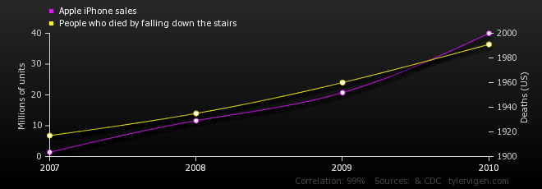](http://tylervigen.com/view_correlation?id=28669)